**ALLICHINA**

**LLANKANA PUSHTUTA**

**¡KAYTA RURAY!**

* Kampak llankaypi kungurisha nishpaka, shuk uchilla bankupi tiary.
* Ashka taligakunata kuyuchisha nishpaka shuk antawatami charini.
* Pupu patapi churay apachinakunata hatachinkapak.
* Hapina o kuyuchina nikpi taligakunata can rraku sinchi churanakunata churanakanki ama tsukrinki. 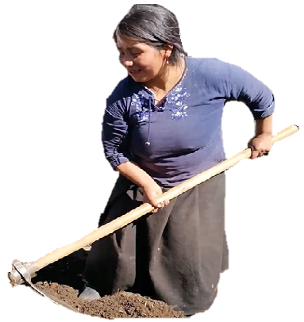

**AMBATO LLAKTAPI HATUN YACHANA WASIMI KAN**

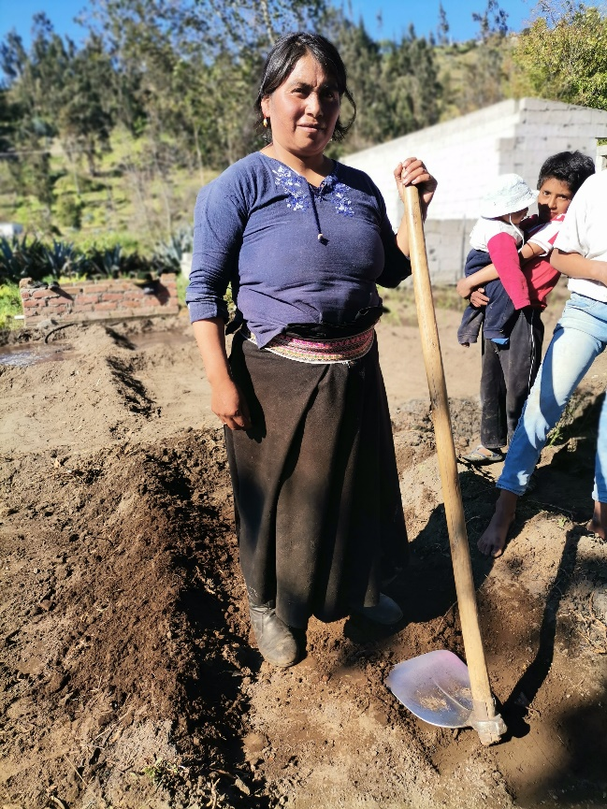

Enter Contact Information Here | 1127 Lombard Blvd. San Francisco, CA 59802 | phone 555.555.5555 | fax 555.555.5555

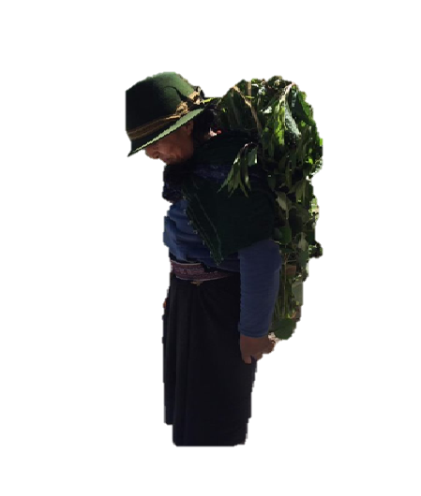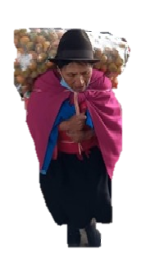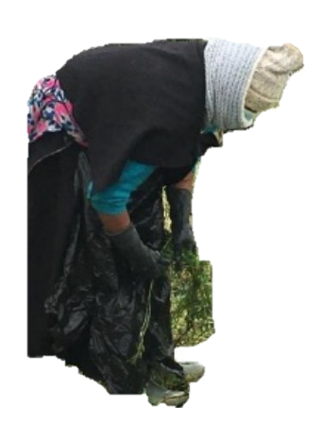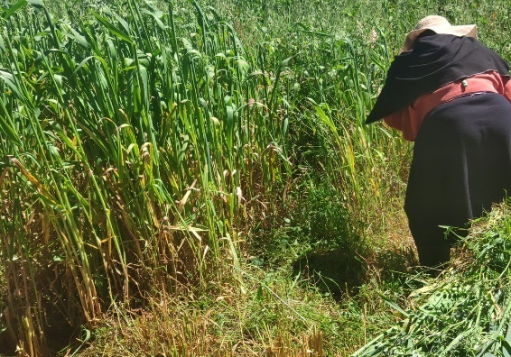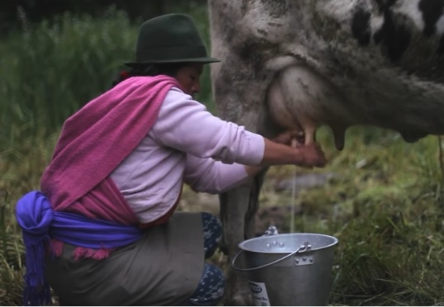

**“Chumbi”**

Chumbita tukuy runa warmi kunapakmi kan anakukunata churarinkapak shinallatak karikunapakpish kanmi runakunallatakmi telarpi awarishpa rurankuna.

**MAKIKUNAWAN TALIGAKUNATA APARISHPA LLANKANA ASHPAPI SHINAWAN WASIPIMI PURISHPA**

**FACULTAD DE INGENIERIA EN SISTEMAS, ELECTRÓNICA E INDUSTRIAL**





**TUPAQMASIN:**

carrera.industrial@uta.edu.ecCdla. Universitaria (Predios Huachi) Call: 2411537Fax: 03-2851894 https://uta.edu.ec/

**Munachiy musuq allpa**

* Taklla
* Hallmaq
* Pallay
* Chakra yapuy killa
* Chilpa
* Chakra qunakuyCurar
* Cpay
* Chakra qutuy pacha

**Chhiki Mana allin “MMC”**

* P'akikuy
* Ch'utu
* Laray
* Balsamu qara
* P'akisqa
* Kuyushca aycha tullu

**Makikunawan taligakunata aparishpa llankana campak sinchi ministini kayta llankankapak: Tankana, chutana, hatachina, charina. Uchilla hatun warmikuna mana ashka aparinakunata aparinachu kan, ishkay chunka kanchis pishca libra kunata aparinakan.**

**MAKIKUNAWAN TALIGAKUNATA**

**Chhik Mawk'ay “Chumbita”**

* Chirumpi
* Nanay
* Ñiqiy
* Nanay rakhu phaka
* Nanachiq
* Nanay rikrapi, washatullupi,

**Yapa willay nikpi**